Assignment 12

1.

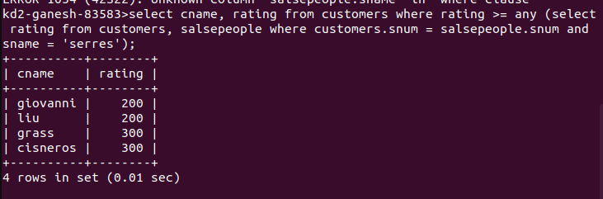

2.

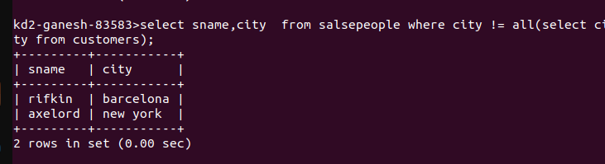
3.
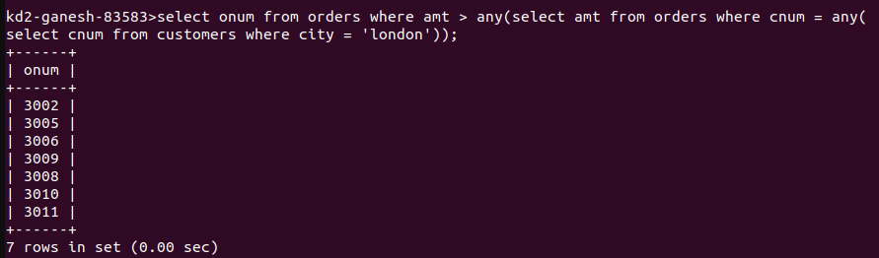

4.

